Project 6: Polynomials and Rectangles

Part 1: Areas of Rectangles
Complete the table with the length, width, and area of each rectangle. Two dimensions are entered in the table.
Rectangle | Length (units) | Width (units) | Area (square units)
Rectangle A  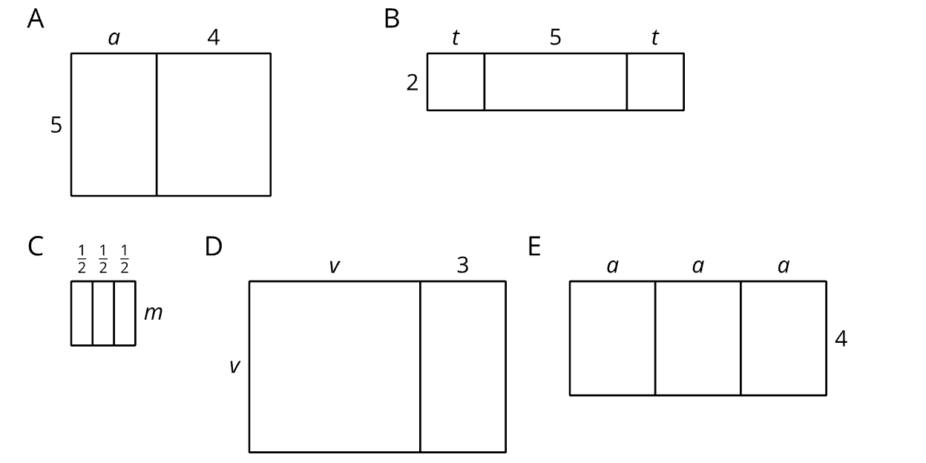 | $$α+4$$
Rectangle B   |  | $$2$$
Rectangle C

Rectangle D

Rectangle E


Part 2: Dimensions and Areas of Rectangles
Use the given information in the table to find the missing length, width, or area of each rectangle. Be prepared to discuss the strategies you used as you found the missing measures.
Rectangle | Length (units) | Width (units) | Area (square units)
A | $$x+3$$ | $$x-4$$
B |  | $$3x-5$$ | $$9x^{2}-25$$
C |  |  | $$x^{2}+8x+16$$
D | $$x-2$$ |  | $$2x^{2}-3x-2$$
E |  | $$x+6$$ | $$x^{2}+4x-12$$
F |  |  | $$x^{2}-16$$
G | $$3x-5$$ | $$3x-5$$
H | $$3x-1$$ | $$x+2$$
I | $$2x-3$$ |  | $$4x^{2}-12+9$$
J |  |  | $$x^{2}+6x-16$$
K | $$2x+3$$ | $$2x-3$$
L |  |  | $$4x^{2}-12xy+9y^{2}-25$$

Part 3: Create Your Own Rectangles
You will use the table to create an activity for your partner to find missing dimensions, similar to the previous activity you completed.
Step 1 - On a separate piece of paper, create three different rectangles (A, B, and C) with length and width formed by degree one binomials. Find the area of each rectangle.
Step 2 - Fill in the table for each rectangle.
- Rectangle A: Fill in the table with the binomials that form the length and width of one of the rectangles you created. Leave the area column blank for rectangle A.
- Rectangle B: Fill in the table with the binomial that represents the length of the second rectangle you created and with the binomial or trinomial that represents the area of the rectangle. Leave the width column blank for rectangle B.
- Rectangle C: Fill in the table with the binomial or trinomial that represents the area of the third rectangle you created. Leave the length and width columns blank for rectangle C.
Rectangle | Length (units) | Width (units) | Area (square units)
A
B
C

Step 3 – Trade tables with your partner.
Step 4 - Each partner works to find the missing information for each of the rectangles their partner created.
Step 5 - Partners compare answers to see if they match. Discuss discrepancies.

